**Coding Challenges - PetPals, The Pet Adoption Platform**

1. Provide a SQL script that initializes the database for the Pet Adoption Platform ”PetPals”.

2. Create tables for pets, shelters, donations, adoption events, and participants.

3. Define appropriate primary keys, foreign keys, and constraints.

4. Ensure the script handles potential errors, such as if the database or tables already exist.

create database PetPals

use PetPals

create table pets

(PetID int primary key,

OwnerID int,

shelterID int,

Name varchar(15),

Age int,

Breed varchar(15),

Type varchar(15),

AvailableForAdoption bit

foreign key(shelterID) references shelters(shelterID))

create table shelters

(ShelterID int primary key,

Name varchar(25),

Location varchar(15))

create table donations

(DonationID int primary key,

ShelterID int,

DonorName varchar(15),

DonationType varchar(15),

DonationAmount decimal(10,2),

DonationItem varchar(15),

DonationDate datetime,

foreign key (shelterID) references shelters(shelterid))

create table adoptionevents

(EventID int primary key,

EventName varchar(35),

EventDate datetime,

Location varchar(20))

create table participants

(ParticipantID int primary key,

ParticipantName varchar(25),

ParticipantType varchar(20),

EventID int,

foreign key (eventid) references adoptionevents(eventid))

insert into pets values

(1,1,1,'ram', 2, 'Labrador', 'Dog', 1),

(2,null,2,'raj', 1, 'Persian', 'Cat', 1),

(3,4,3,'charles', 3, 'Beagle', 'Dog', 0),

(4,5,4,'rina', 4, 'Siberian', 'Cat', 1),

(5,null,5,'ravi', 2, 'persian', 'Dog', 1),

(6, 7,6,'sam', 6, 'German Shepherd', 'Dog', 0),

(7,9,7,'shiv', 1, 'Ragdoll', 'Cat', 1),

(8, null,8,'murali', 3, 'Bulldog', 'Dog', 1)

insert into shelters values

(1,'Happy Paws Shelter', 'New York'),

(2,'Safe Haven Shelter', 'Los Angeles'),

(3,'Purrfect Rescue', 'Chicago'),

(4,'Furry Friends Home', 'Houston'),

(5,'Paw Haven', 'San Francisco'),

(6,'Adopt Me Shelter', 'Miami'),

(7,'Home for Paws', 'Seattle'),

(8,'Rescue World', 'Denver')

insert into donations values

(1,1,'John Doe', 'Cash', 100.00, null, '2025-04-10 10:00:00'),

(2,2,'Jane Smith', 'Item', null, 'Dog Food', '2025-05-10 10:00:00'),

(3,3,'Emily Davis', 'Cash', 200.50, null, '2025-12-10 10:00:00'),

(4,4,'Michael Brown', 'Item', null, 'Cat Toys', '2025-02-10 10:00:00'),

(5,5,'Sarah Wilson', 'Cash', 50.00, null, '2025-11-10 10:00:00'),

(6,6,'Chris Johnson', 'Item', null, 'Blankets', '2025-04-10 10:00:00'),

(7,7,'Laura White', 'Cash', 300.00, null, '2025-04-10 10:00:00'),

(8,8,'Kevin Harris', 'Item', null, 'Leashes', '2025-12-10 10:00:00')

insert into adoptionevents values

(1,'Paws for a Cause', '2025-04-10 10:00:00', 'New York'),

(2,'Adopt-A-Pet Fair', '2025-05-15 12:00:00', 'Los Angeles'),

(3,'Forever Home Event', '2025-06-01 09:30:00', 'Chicago'),

(4,'Rescue Me Adoption Day', '2025-07-20 14:00:00', 'Houston'),

(5,'Furry Friends Meetup', '2025-08-05 11:00:00', 'San Francisco'),

(6,'Happy Tails Adoption', '2025-09-12 13:00:00', 'Miami'),

(7,'Love a Pet Day', '2025-10-30 15:00:00', 'Seattle'),

(8,'Adoption Fest', '2025-11-25 16:30:00', 'Denver')

insert into participants values

(1,'Happy Paws Shelter', 'Shelter', 1),

(2,'Safe Haven Shelter', 'Shelter', 2),

(3,'Purrfect Rescue', 'Shelter', 3),

(4,'Furry Friends Home', 'Shelter', 4),

(5,'John Doe', 'Adopter', 5),

(6,'Jane Smith', 'Adopter', 6),

(7,'Chris Johnson', 'Adopter', 7),

(8,'Laura White', 'Adopter', 8)

--5--Write an SQL query that retrieves a list of available pets (those marked as available for adoption)

--from the "Pets" table. Include the pet's name, age, breed, and type in the result set. Ensure that

--the query filters out pets that are not available for adoption.

select name, age, breed, type from pets where availableforadoption = 1

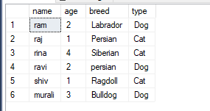

--6--Write an SQL query that retrieves the names of participants (shelters and adopters) registered

--for a specific adoption event. Use a parameter to specify the event ID. Ensure that the query

--joins the necessary tables to retrieve the participant names and types.

select p.participantname, p.participanttype, a.eventname from participants p

join adoptionevents a on p.eventid = a.eventid

where p.eventid = 2

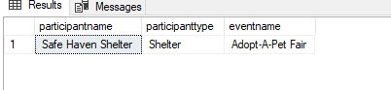

--8--Write an SQL query that calculates and retrieves the total donation amount for each shelter (by

--shelter name) from the "Donations" table. The result should include the shelter name and the

--total donation amount. Ensure that the query handles cases where a shelter has received no

--donations.

select s.name as shelter_name, sum(d.donationamount) as total_donation from shelters s

left join donations d on s.shelterid = d.shelterid

group by s.name

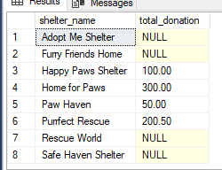

--9--Write an SQL query that retrieves the names of pets from the "Pets" table that do not have an

--owner (i.e., where "OwnerID" is null). Include the pet's name, age, breed, and type in the result

--set.

select name, age, breed, type from pets where OwnerID is null  
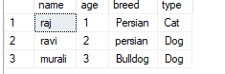

--10--Write an SQL query that retrieves the total donation amount for each month and year (e.g.,

--January 2023) from the "Donations" table. The result should include the month-year and the

--corresponding total donation amount. Ensure that the query handles cases where no donations

--were made in a specific month-year.

select format(donationdate, 'MMMM yyyy') as month_year, sum(donationamount) as total_donation from donations

group by format(donationdate, 'MMMM yyyy')  
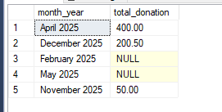

--11--Retrieve a list of distinct breeds for all pets that are either aged between 1 and 3 years or older than 5 years.

select distinct breed from pets

where (age between 1 and 3) or (age > 5)

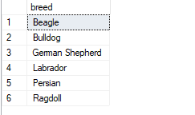

--12--Retrieve a list of pets and their respective shelters where the pets are currently available for adoption.

select p.petid, p.name as pet_name, p.breed, p.type, s.shelterid, s.name as shelter_name from pets p

join shelters s on p.shelterid = s.shelterid

where p.availableforadoption = 1

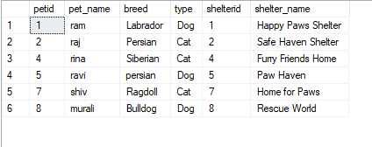

--13--Find the total number of participants in events organized by shelters located in specific city. Example: City=Chennai

select count(p.participantid) as total_participants from participants p

join adoptionevents e on p.eventid = e.eventid

join shelters s on e.location = s.location

where s.location = 'New York'

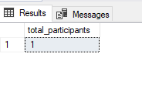

--14--Retrieve a list of unique breeds for pets with ages between 1 and 5 years.

select distinct breed from pets

where age between 1 and 5

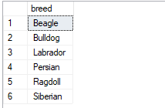

--15--Find the pets that have not been adopted by selecting their information from the 'Pet' table.

select name, age, breed, type from pets

where ownerid is null

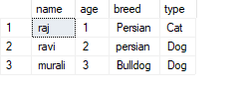

--16--Retrieve the names of all adopted pets along with the adopter's name from the 'Adoption' and 'User' tables.

select petid, name as pet_name, ownerid from pets

where ownerid is not null

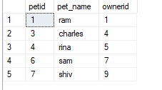

--17-- Retrieve a list of all shelters along with the count of pets currently available for adoption in each shelter.

select shelterid, count(*) as available_pets

from pets

where availableforadoption = 1

group by shelterid

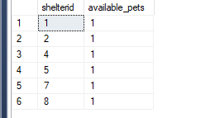

--18-- Find pairs of pets from the same shelter that have the same breed.

select shelterid, breed, count(*) as pet_count

from pets

group by shelterid, breed

having count(*) > 1

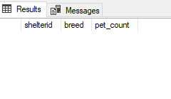

--19--List all possible combinations of shelters and adoption events.

select s.shelterid, s.name as shelter_name, e.eventid, e.eventname

from shelters s

cross join adoptionevents e

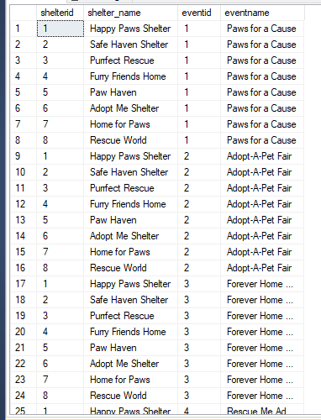

--20-- Determine the shelter that has the highest number of adopted pets.

select top 1 shelterid, count(*) as adopted_pets from pets

where ownerid is not null

group by shelterid

order by adopted_pets desc

